

BelgicaWeb – Sustaining access to Belgium’s born-digital heritage
___________________________________________________________________________
Deliverable 2.1.1 Report on technical and functional requirements based on researcher needs, state of the art of access to born-digital collections and analysis of KBR technical infrastructure
&
Deliverable 3.1.1 Report on technical and functional requirements based on researcher needs and state of the art of data enrichment
(M10 : M16)
___________________________________________________________________________

Editors | Julie Birkholz  Friedel Geeraert  Isabelle Gribomont  Peter Mechant  Christina Vandendyck  Eveline Vlassenroot
Responsible partners | KBR  UGhent (MICT, GhentCDH)
Version | V01
How to cite this? | Friedel Geeraert, Christina Vandendyck, Eveline Vlassenroot. (July 2025). Deliverable 2.1.1 Report on technical and functional requirements based on researcher needs, state of the art of access to born-digital collections and analysis of KBR technical infrastructure & Deliverable 3.1.1 Report on technical and functional requirements based on researcher needs and state of the art of data enrichment

1 Introduction 4
2 Methodology 4
3 Results 6
3.1 General information about survey respondents (sociodemographic) 6
3.2 Topic 1 “Researcher needs in terms of content selection and implementation” 13
3.2.1 Who selects content 13
3.2.2 Which content 15
3.2.3 Assuming there are no practical or legal hurdles, how do you see the content selection of a web and social media archive? 19
3.2.4 Best practice for content selection and implementation 19
3.2.5 Combined Insights from workshops – Content selection 20
3.3 Topic 2 “Researcher needs in terms of access and implementation of (pilot) API and access platform” 21
3.3.1 Interface functionalities 21
3.3.2 Search results 25
3.3.3 Assuming there are no practical or legal hurdles, how do you see the access to a web and social media archive via a user interface? 33
3.3.5 Functionalities API 34
3.3.6 Assuming there are no practical or legal hurdles, how do you see the access to a web and social media archive via API? 38
3.3.7 Best practice in terms of access and API 38
3.3.8 Combined Insights from workshops – Access 39
3.4 Topic 3 “Researcher needs in terms of content enrichment and implementation for enrichment” 40
3.4.1 State of the art of content enrichment 40
3.4.1 Content enrichment 41
3.4.2 Assuming there are no practical or legal hurdles, how do you see the enrichment of web and social media archived content? 44
3.4.3 Best practices for enriching 44
3.4.4 Combined insights from workshops – Content enrichment 45
4 Conclusions 46
Annex I: Outline workshop DH Benelux 47
Annex II: Presentation workshop DH Benelux 47
Annex III: Outline workshop Praktijknetwerk 47
Annex IV: Presentation workshop Praktijknetwerk 47
Annex V: Survey questions 47
Annex VI: Survey results 47
Annex VII: Analysis of access platforms and user interfaces 47
Annex VIII: MoSCoW table outlining the planned development based on survey results 48

1 Introduction
This report presents a study conducted to identify and map the specific user requirements for web and social media archives. Researchers, librarians, archivists, and other stakeholders who engage with these digital resources were the focus. The central research question is: “What are user requirements for web and social media archives?” The study aimed to understand the needs and practices of diverse user groups to optimize the usability and effectiveness of these archives. By gathering detailed feedback, the study sought to inform the development of tools, interfaces, and methodologies that align with user expectations and support effective research and analysis.
Web and social media archives have become important resources for studying human behavior and cultural history, but their effective use depends on addressing challenges such as content selection, curation, access, and data enrichment. To explore these areas, the study employed a combination of workshops and a survey to collect data from users across academic, professional, and heritage sectors. This approach allowed for a comprehensive analysis of the requirements necessary to enhance web and social media archiving practices.

2 Methodology
The study employed a mixed-methods approach, incorporating two interactive workshops and a survey to gather data. The first workshop was conducted as part of the DH Benelux conference on June 4 2024 in Leuven and focused on enhancing the accessibility and research potential of born-digital archived content (see Annex I & II). Participants explored challenges in three conceptual phases: (1) orientating, which examined institutional policies and strategies shaping archive accessibility; (2) auditing, which assessed the history of collection practices and barriers to access; and (3) constructing, which involved discussions on enriching and aggregating archived data for research purposes. This workshop, lasting three hours, facilitated in-depth discussions and collaborative problem-solving among participants.
The second workshop was held during the “Praktijknetwerk Sociale Media Archiveren” event on October 15 2024 in The Hague and employed a persona-based approach to examine user engagement with social media web archives (see Annex III & IV). Participants worked in groups representing different BESOCIAL personas, immersing themselves in the personas’ perspectives. Each group selected web archive use cases for exploration and discussed three core topics: content selection, user-friendly access through interfaces or APIs, and methods for enriching archived content. These discussions generated practical insights into improving web archives to better meet the needs of diverse user groups.
To complement the workshops, a survey was set up to collect broader insights into user requirements (see Annex V & VI). In preparation for the survey a non-exhaustive analysis of access platforms and search interfaces was done in which the key features of each were extracted. This allowed the BelgicaWeb team to quickly gain an overview of the state of the art of access platforms and search interfaces for web and social media archives. The results of this analysis can be found in Annex VIII. The access platforms and search interfaces of the web and social media archives held by the following institutions were analysed: the Wayback Machine, Arquivo.pt (Portugal), Archive.is (National and University Library of Iceland), Archive-It, SOMAR (SOcial Media ARchive) held by the University of Michigan Institute for Social Research, the SolrWayback instance at the National Széchényi Library (National Library of Hungary), the Library of Congress and InA in France (Institut national de l’Audiovisuel). This served as a starting point and helped formulate the survey questions. The results of a brainstorming session with the BelgicaWeb team about other potential features and functionalities were then also added to the survey questions.
The survey ran from October 9 2024 till January 13 2025. To maximize outreach and participation, the survey was distributed through a variety of targeted channels. It was shared with an expert panel via Teams and email, as well as with contacts from the BESOCIAL and PROMISE projects. The survey link was included in the KBR newsletter and shared through relevant mailing lists such as IIPC, JISC, RESAW, and IFLA. It was also promoted within digital humanities communities, including DH Benelux and the DH Early Career Researcher Virtual Discussion Group. A temporary pop-up was added to the KBR website and catalogue to attract visitors organically. Additionally, the survey was promoted on social media channels of KBR and partner institutions, and efforts were made to engage organisers of the Praktijknetwerk Sociale Media Archiveren and researchers at UCLouvain to support further distribution. The survey explored four key areas: content selection, search interface functionalities, API access, and content enrichment, while also collecting basic demographic information and details on respondents’ experience with web archives. This multi-channel dissemination strategy ensured diverse participation, including researchers, librarians, and professionals from libraries, archives, and heritage institutions.
The survey findings were then translated into practical designs, infrastructure choices. The BelgicaWeb team did a MoSCoW analysis. MoSCoW is a prioritisation technique used in software development to determine priorities with stakeholders. The BelgicaWeb team attributed a Must have, Should have, Could have and Won’t have category to each of the requirements that were indicated in the survey responses based on two criteria: desirability (based on the survey responses) and feasibility (based on the available human resources within the BelgicaWeb team). In addition, the free text responses to ‘Other’ questions in the survey were also assessed by participants in a third BelgicaWeb workshop held during the RESAW conference in Siegen (June 5-6). The Wooclap tool was used to score each of the additional requirements (see list of questions in Annex IX) and were then attributed a MoSCoW category. The resulting Excel table that is included in Annex VIII shows which features will be developed for the BelgicaWeb access platform and API. It also shows which features are already included in the SolrWayback tool because this tool is favored by the web archiving community. This approach has allowed us to align the development within the project with the user requirements and needs.

3 Results
The survey received 384 unique views, which represent the number of people who opened the first page of the survey. However, not all of these viewers proceeded to complete it. In total, 75 participants provided complete responses to the three main thematic sections: content selection and implementation, access, and enrichment. Additionally, 32 respondents completed the section on the Web Archival Literacy Scale.

The survey results can be viewed via
https://public.tableau.com/app/profile/eveline.vlassenroot/viz/BelgicaWeb1/BelgicaWeb?publish=yes
Other annexes including the survey questions (Annex V) and survey results (Annex VI) can be accessed via https://www.sodha.be/dataset.xhtml?persistentId=doi:10.34934/DVN/NHLLHP

3.1 General information about survey respondents (sociodemographic)
The group of respondents is predominantly composed of highly educated individuals, with most holding either a Master’s degree (39 respondents) or a PhD (29). In terms of age, the majority fall between 25 and 44 years old, specifically within the 35–44 (22 respondents) and 25–34 (21) age brackets, indicating a mid-career demographic.

Gender representation is relatively balanced, with 44 identifying as male and 36 as female. Most participants are Belgian (46), though several other nationalities are represented in smaller numbers. Professionally, the group includes a wide range of roles, most notably archivists (15), librarians (12), professors (11), and PhD students (8), alongside 16 who selected "Other" as their role.

A significant portion of the group has extensive professional experience, with 43 respondents reporting over 10 years of expertise and 19 reporting 5–10 years. Nearly all participants (77) have visited a web or social media archive before, and 65 have worked with archived content. In terms of frequency, engagement with such archives varies: 19 use them a few times a year, 16 use them 2–3 times a week, and 12 consult them daily, indicating that for many, web and social media archives are a regular part of their professional activities.

Below are tables with this sociodemographic information:

- Age

Age | Count of Age
18-24 | 5
25-34 | 21
35-44 | 22
45-54 | 15
55-64 | 9
65-74 | 8
75-84 | 1
85+ | 2
Blank | 3
Total | 86

- Gender
Gender | Count of Gender
Male | 44
Female | 36
Prefer not to say | 1
Unspecified | 2
Blank | 3
Total | 86

- Nationality:
Nationality | Count of Nationality
American | 4
Austrian | 1
Belgian | 46
Blank | 3
British | 5
Canadian | 1
Danish | 2
Dutch | 2
Finnish | 1
French | 9
Greek | 1
Italian | 3
Luxembourger | 1
Norwegian | 1
Polish | 1
Slovenian | 1
Spanish | 1
Swiss | 1
Turkish | 2
Total | 86

- Level of education
Level of education | Count of Level of eduction
Secondary school | 9
Bachelor's degree | 5
Master's degree | 39
PhD | 29
Blank | 4
Total | 86

- Current job role
Job role | Count of Job role
(Independent) researcher | 5
Archivist | 15
Faculty member | 5
Librarian | 12
Masters student | 3
PhD student | 8
Postdoctoral researcher | 5
Professor | 11
Undergraduate student | 3
Other (you will be asked to specify in a next question) | 16
Blank | 3
Total | 86
- Main discipline
Primary/main discipline, area of study, or area of interest | Count of Primary/main discipline, area of study, or area of interest
(Visual) arts | 2
Archaeology | 1
Blank | 3
Educational sciences | 1
Genealogy/family history | 4
History | 22
Information sciences | 19
Law | 1
Linguistics and languages | 4
Literature | 4
Media and communications | 4
Other (you will be asked to specify in a next question) | 14
Performing arts | 4
Political sciences | 1
Religion | 1
Social and economic geography | 1
Total | 86

- Years of expertise
Year(s) of expertise | Count of Year(s) of expertise
Less than 1 year | 1
1-3 years | 6
3-5 years | 15
5-10 years | 19
10 years or more | 43
Blank | 2
Total | 86

- Visited a web and social media archive
Visited a web and social media archive before (yes/no) | Count of Visited a web and social media archive before
Yes | 77
No | 7
Blank | 2
Total | 86

- Experience with archived web or social media content
Worked with archived web or social media content (yes/no) | Count of Worked with archived web or social media content
Yes | 65
No | 17
I don't know | 2
Blank | 2
Total | 86

- Frequency of consulting
Frequency of consulting | Count of Frequency
Daily | 12
2-3 times a week | 16
Once a week | 10
Monthly | 7
2-3 times a month | 4
A few times a year | 19
Yearly | 4
Never | 2
Blank | 4
Total | 78
- Level of expertise (subjective)
Level of expertise in using/working with web and social media archives (subjective) | Count of Level of expertise
1 | 8
2 | 7
3 | 16
4 | 24
5 | 11
Blank | 11
Total | 77
The following section presents the results of the study, which are organized into three main topics reflecting the core needs of researchers: (1) content selection and implementation, (2) access and use of APIs and user interfaces, and (3) content enrichment. Within each topic, the results are based on data collected through surveys, as well as insights gained from two workshops as explained in the methodology.
For Topic 1, which focuses on content selection and implementation, sections 3.2.1 through 3.2.4 present findings from the survey. Section 3.2.5 includes the insights gathered during the workshops.
For Topic 2, which addresses access and the use of APIs and interfaces, sections 3.3.1 to 3.3.7 are based on survey responses. Section 3.3.8 summarizes the outcomes of the workshop discussions on this topic.
For Topic 3, which explores content enrichment, sections 3.4.1 to 3.4.3 present the survey results, while section 3.4.4 contains the insights from the workshops.

3.2 Topic 1 “Researcher needs in terms of content selection and implementation”

3.2.1 Who selects content
The primary insights regarding who selects content for web archiving reveal a strong preference for institutional expertise. The most favored roles in determining selection criteria are "the team of web archivists at the managing institution" and "curators or experts at the institution," with 67 and 61 out of 80 respondents, respectively, rating these as very important. This indicates a high level of trust in the knowledge, training, and judgment of in-house professionals to guide the curation of web archive collections.
The strong support for institutional decision-making reflects a belief in the value of structured, expert-led approaches to content selection. However, there is also a notable openness to external contributions, suggesting a desire for broader, more diverse perspectives in the archival process. This interest likely reflects an understanding that no single group can capture the full range of relevant voices, communities, or events online—especially given the dynamic and multifaceted nature of the web.
In addition to the predefined selection roles, several “other” responses provided further nuance. One respondent emphasized the importance of ensuring that archived content is accurate and diverse, stating that titles and names must reflect correct information—highlighting a concern for both representation and data integrity. Another respondent underscored a more inclusive philosophy, expressing that "every contribution is worth taking," reinforcing the value of openness and plurality in the archiving process.
A third respondent noted that while expert guidance is essential, it is ultimately “the human labor”—organized and directed by these experts—that plays a key role in selection. According to this perspective, the decisive element is not only who chooses the content but how that work is structured and carried out in practice, with much of the process subsequently delegated to automated systems for classification and processing.
Together, these perspectives affirm the importance of professional curation while also emphasizing the value of inclusivity, accuracy, and human-centered workflows in content selection. They suggest that while institutional expertise provides a crucial foundation, a collaborative and flexible approach may be best suited to meeting the evolving challenges of web archiving.

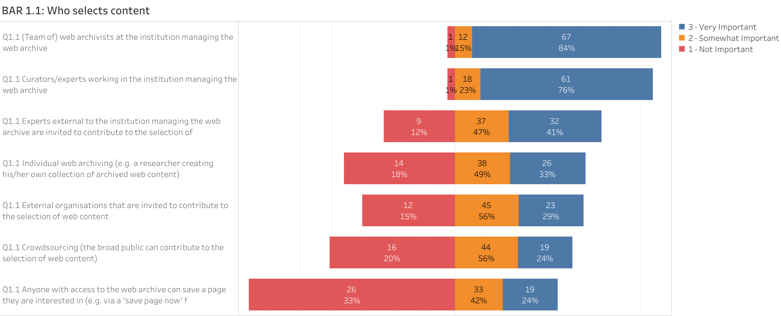

3.2.2 Which content
When it comes to selecting content for web archiving, text stands out as the most highly prioritized format. Of the 79 respondents, 86% rated text as very important, indicating its foundational role in research, interpretation, and long-term preservation. This strong preference reflects the centrality of textual materials in documenting information, discourse, and context across the web.
Following closely behind, images were rated as very important by 70% of respondents, emphasizing the value of visual content in capturing events, culture, and communication patterns. Similarly, thematic curated collections—in-depth captures of a limited number of web resources—were rated as very important by 66%, and event-based collections by 61%. These findings suggest that respondents not only prioritize individual content types but also favor organized, purpose-driven collections that provide contextual richness and research relevance.
More general and automated approaches, such as broad crawls (64% very important) and video content (56%), also received significant support, though with slightly more variation in perceived importance. This reflects a growing recognition of the need to include a diverse range of formats and methods for capturing the web, while still maintaining some prioritization around specificity and usability.
Features such as preserving the look and feel of web content, collecting user-generated content (e.g. comments, likes, shares), and using AI-driven selection techniques were generally viewed as less essential. Only 42% rated the visual preservation of look and feel as very important, while user-generated content and AI-based selection were rated very important by 38% and 15%, respectively. These lower scores suggest that, while such features may enhance the completeness or scalability of archives, they are not considered core priorities by most respondents.
The “other” responses added additional nuance to these preferences. Several respondents emphasized the importance of content types not explicitly listed in the survey. Audio content and sound were described as very important, underscoring a desire to expand beyond visual and textual material to include oral and acoustic dimensions of online communication. Downloadable files—such as PDFs or datasets—were also rated as very important, reflecting practical needs for research-ready formats. Another respondent called attention to content behind paywalls, identifying a significant area of concern for accessibility and preservation. Meanwhile, social media policies and user statistics were noted as somewhat important, pointing to emerging areas of interest in how platforms operate and how users engage.
Finally, one response highlighted the importance of capturing personal contributions across the web, reinforcing the value of user-generated, grassroots content that might otherwise be overlooked. Altogether, these insights reflect a preference for foundational content types like text and images, complemented by a growing awareness of the broader diversity of web materials that may be critical for comprehensive, representative archiving.

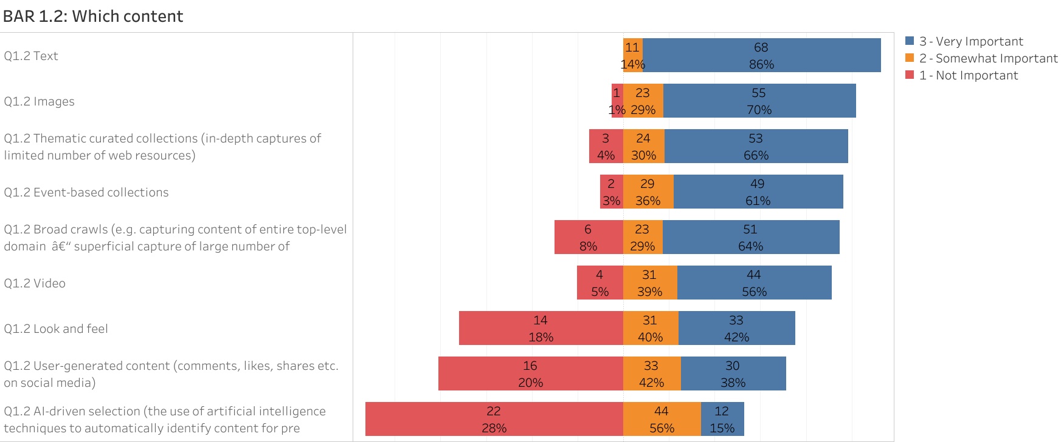

3.2.3 Assuming there are no practical or legal hurdles, how do you see the content selection of a web and social media archive?
The responses from the survey reflect a clear and shared aspiration: if practical and legal hurdles were removed, content selection for web and social media archives should be as broad, inclusive, and representative as possible, both nationally and internationally. The prevailing belief is that digital content, like traditional records, constitutes vital cultural heritage that must be preserved comprehensively for future research, public memory, and civic understanding.
Many advocate a "collect-everything" approach—similar to the Wayback Machine or Arquivo.pt—especially for publicly available material. This includes news sites, blogs, social media posts, forums, and other dynamic web content. At the same time, respondents call for strategic selection driven by both curatorial expertise and user needs, incorporating national events, public discourse, political moments, and thematic interests. This dual approach—broad, automated collection combined with targeted, human-guided curation—emerges as a best practice.
Clear support also exists for decentralized and collaborative selection models, including public nominations, participatory archiving, and thematic or institutional contributions coordinated through central systems. Suggestions range from allowing individuals to curate and donate their own digital footprints to involving educators in shaping collections for pedagogical use. Some even propose gamified or exploratory features (e.g., GeoGuessr-style discovery games) to engage younger or non-specialist users.
Crucially, respondents stress the need for sufficient IT support, not only for collection at scale, but also for the development of user-facing tools that allow browsing, analysis, and interpretation. Legal deposit legislation that supports open access and ethical use is seen as essential. At the same time, there's recognition that preservation must be accompanied by transparency—archiving not just content, but also its metadata, context, and the rationale behind its selection.
Finally, ethical reflection is paramount. Calls for data diversity, bias awareness, multilingualism, and inclusive representation underpin many responses. Contributors stress that today’s web is tomorrow’s historical record—and the more holistic and unbiased its curation, the more valuable it will be to future generations.

3.2.4 Best practice for content selection and implementation
A best practice for web and social media archiving in terms of content selection and implementation combines strategic curation, broad scope, clear documentation, and collaborative infrastructure. Among the most cited examples, the Wayback Machine stands out for its international coverage, historical depth, and open access. Its dual approach—automated large-scale crawling alongside curated collections—offers both comprehensiveness and contextual relevance, making it indispensable for global digital heritage.
Equally commendable are initiatives like the British Library, INA (France), Arquivo.pt, and the Library of Congress, which each excel in different areas: from thematic and event-based collections to user-nomination systems and preservation of government or institutional web presence. These projects demonstrate that effective content selection is not only about collecting “everything,” but about implementing transparent criteria, ensuring representative sampling, and involving both archivists and domain experts in the decision-making process.
Best practices also emphasize the importance of metadata and technical transparency: clearly stating what has been archived, how often, what was missed (and why), and how the crawl was technically implemented. Publicly accessible documentation—like the Library of Congress’ Social Media Collection Policy or Arquivo.pt’s capture statistics—help set a precedent for ethical, thoughtful web archiving.
Respondents also highlight the need for participatory models, where researchers, institutions, and even the public can nominate content for archiving. This ensures the archive remains dynamic and responsive to evolving cultural, political, and social relevance. Involving educators, historians, and even youth-focused initiatives can enrich archives for broader audiences.
Lastly, successful implementation depends on strong technical infrastructure (e.g., tools for dynamic site capture, scalable storage), international cooperation, and interoperable standards that avoid duplication and promote shared development. Whether through large-scale crawls, institutional partnerships, or thematic deep dives, the best implementations are those that balance depth and breadth, adapt to the changing web, and commit to serving diverse future research needs.

3.2.5 Combined Insights from workshops – Content selection
Across both workshops, participants emphasized that content selection should be transparent, inclusive, and user-informed. There was broad agreement that the process should be guided by neutral and independent institutions, but should also enable participatory models where researchers, institutions, or even the public can nominate or contribute content.

Participants stressed the importance of clearly documenting who selected the content, what was included or excluded, and the rationale behind those decisions. They also advocated for a broad and inclusive approach to content types, including non-traditional formats such as memes, gifs, multimedia, deleted posts, user-generated comments, and citizen journalism. These forms of content are considered essential for capturing the full spectrum of online discourse.

There was a clear demand for advanced corpus-building tools that enable users to create datasets based on specific linguistic patterns, thematic categories, publication platforms, or timeframes. Such tools would support both exploratory research and focused, question-driven analysis.
In addition, participants raised important ethical considerations around content selection. These included the distinction between public and private online content, the need to handle deleted or sensitive material with care, and the importance of fairness and diversity in what is collected and preserved.

3.3 Topic 2 “Researcher needs in terms of access and implementation of (pilot) API and access platform”

3.3.1 Interface functionalities
Among the interface functionalities, advanced search was identified as the most important feature, with 62 out of 78 respondents indicating it as very important. This strong preference highlights the central role of advanced search capabilities in enabling users to efficiently navigate and retrieve content within web and social media archives. Closely following in importance were functionalities such as the ability to search for text strings within specific websites or page text, browsing databases of archived social media, performing URL-based searches, browsing curated collections, and multilingual search support. These findings point to a clear expectation for interfaces that support targeted discovery and flexible navigation across large and complex collections (see Table 3 for detailed rankings).
In addition to the predefined options, a number of “other” responses offered valuable insights and suggested functionalities not explicitly included in the ranking exercise. Several of these were also described as very important by respondents. These include the ability to export data derivatives, which supports further analysis and integration into external research workflows. Similarly, respondents emphasized the value of having a folder system or comparable functionality that allows individual users or research groups to save and organize search results—a feature that aligns closely with collaborative and longitudinal research practices. Others highlighted the importance of exportability more broadly, particularly for ensuring data accessibility and reuse beyond the immediate interface.
Quantification and visualization of collections were also cited as very important, indicating a desire for tools that not only facilitate access to data but also enable users to understand its scope, distribution, and key features at a glance. This points to an interest in interfaces that offer both granular control and high-level interpretive support.
Beyond specific functionalities, some respondents reflected on the broader context of interface development. One respondent noted that having an interface is not always necessary or possible, especially given the variety of data formats involved—such as hashtags stored in .jsonl, Facebook data available in .html, or .warc formats. In some cases, it may be more practical for archived web or social media data to be integrated into traditional archival inventories rather than presented through a dedicated interface. Others emphasized the need to consider development and especially long-term maintenance costs when deciding which features to support, arguing for a conservative approach that prioritizes sustainability. Additionally, one respondent pointed out that the ranking question did not include a “no opinion” option, which may have influenced how respondents rated certain features they were less familiar with or felt were outside the scope of their use.
Finally, one comment clarified that their understanding of advanced search includes the ability to combine multiple criteria—such as dates, places, and keywords—suggesting that the term may encompass a range of complex query-building functions. Taken together, these responses reflect both a strong interest in practical, research-oriented tools and a clear awareness of the technical, infrastructural, and strategic considerations that underpin interface development.

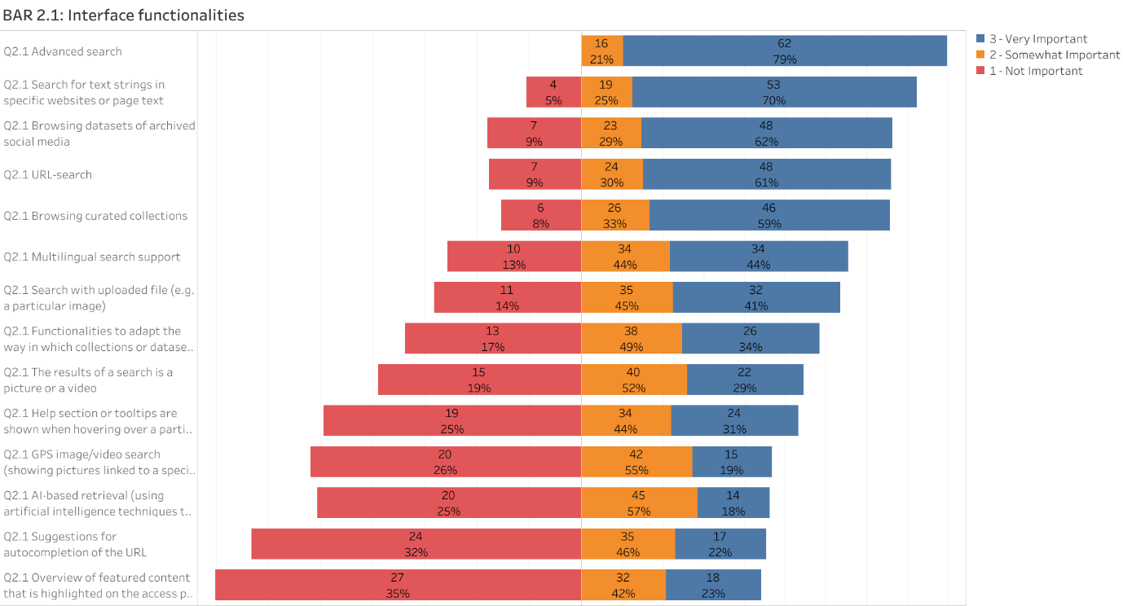

More detail on advanced search (respondents who have indicated “advanced search” as “very important”)
The availability of advanced search options is critical. Respondents highly value the ability to conduct searches based on specific words or phrases, and the use of filters to narrow down searches to specific domains or time frames. This allows for more precise and relevant search results, facilitating efficient data retrieval.
In the “other” section respondents mentioned the ability to search for specific visual or audio objects via image or sound recognition. The ability to search for posts that cite or repost other messages received a lower importance ranking of all 14 options.

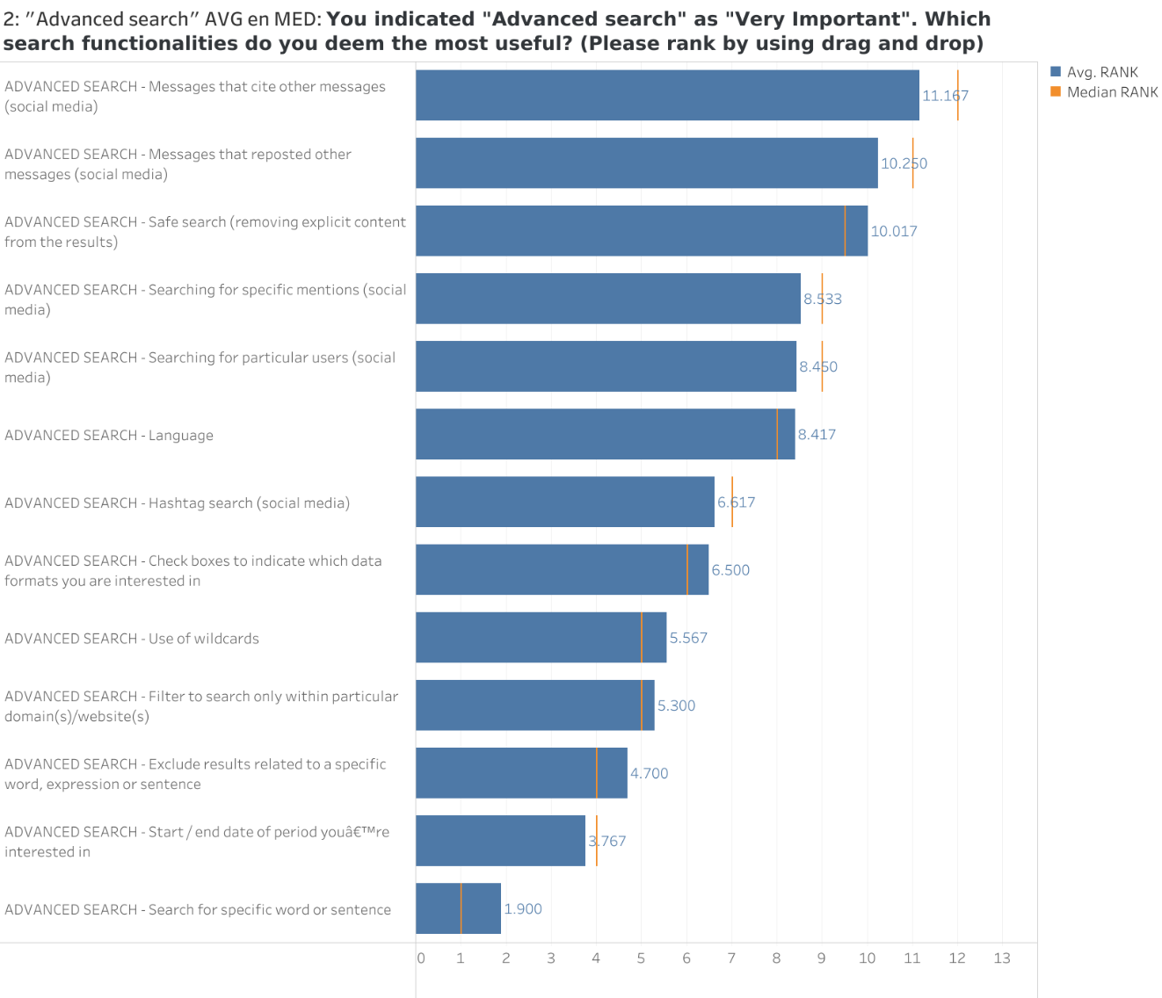
Note: Respondents were asked to rank the items from most useful (ranked as 1) to least useful (ranked as 14). A lower number indicates a higher usefulness. This graph is not included in the Tableau dashboard since this question was not presented to everyone, only the respondents who indicated “Advanced search” as “Very Important”.

3.3.2 Search results
The chart reveals that users place the highest value on practical and functional features that enhance usability and accessibility. For example, the ability to export and download search results is considered very important by a significant majority of respondents (77%). Similarly, filtering options—such as filtering by content type, location, or capture date—are rated as very important by 70% of users.
Another highly valued feature is having clear information about rights and access conditions, which is essential for ethical and legal use of archived content. This was rated very important by 66% of users. The ability to sort and rank results (such as relevance or chronological order) also scored highly, with 57% rating it as very important.
Several features are seen as somewhat important rather than critical. These include a temporal overview with visualization options (like a calendar view), an overview of all URLs included in the results, and guidelines for citing content. These features still add value but are not seen as essential by most users.
Features such as automatic links to similar items, site structure graphs, and summary statistics are generally rated lower in importance. Many users marked them as only somewhat important or even not important at all. The lowest-rated features include buttons for sharing search results and the integration of automatic narrative creation, which were considered not important by over 40% of users.
In addition to the listed features, there was one “Other” response submitted in the survey. This respondent noted that stable URIs for captures are very important, emphasizing the value of persistent links for referencing specific archived content reliably over time.

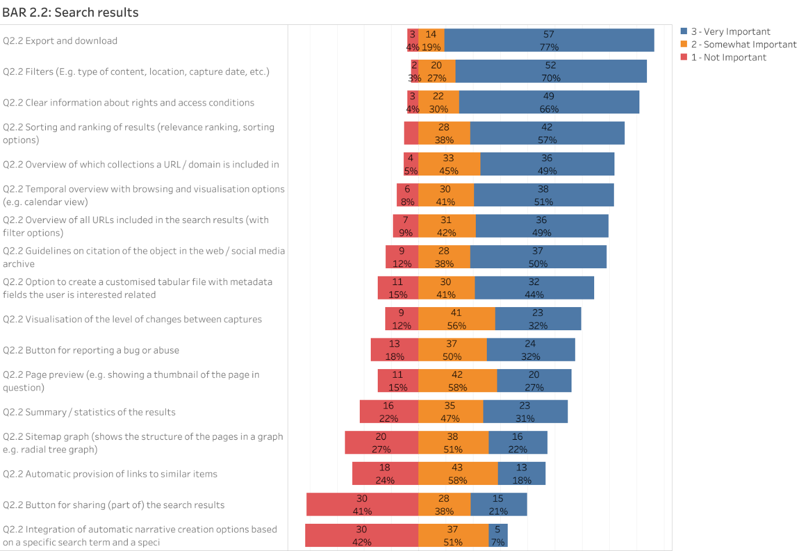

More detail on export and download (respondents who have indicated “export and download” as “very important”)
Export and download functionalities are regarded as essential by many respondents, particularly for enabling further analysis and reuse of archived data. The ranking results show a clear preference for formats that are versatile, structured, and widely supported across research tools and workflows.
CSV ranked as the most preferred export format, with the lowest average rank (2.29), indicating strong favorability. This is likely due to its simplicity, compatibility, and ease of use in spreadsheets and data processing environments. Close behind were JSON and TXT formats, with average ranks of 3.29 and 4.57 respectively. These formats are particularly valued for their flexibility and readability in both programmatic and manual inspection contexts.
WARC, XLSX, and ODS followed next in the rankings, with moderate preference levels. These formats support the preservation of structured or web archive data and are especially useful in more specialized analytical contexts. Similarly, export of links for visualization tools such as Gephi ranked in the middle range, reflecting its utility in network analysis but narrower applicability.
On the visual side, formats like JPEG, PNG, RDF, and SVG appeared further down the ranking, though SVG and RDF still showed relatively strong average preferences (9.43 and 8.86). This suggests that while not the top priority, these formats are still important for users involved in visualization, semantic web technologies, or linked data environments.
The “Other” responses add valuable depth and point to emerging or niche needs that may not be fully captured by the standard export options. JSONL (line-delimited JSON), PDF, and WACZ (Web ARChive Zipped) were each ranked as a top preference by at least one respondent. This suggests strong interest in formats that preserve structural detail (WACZ), support standardized document sharing (PDF), or align with streaming-friendly data workflows (JSONL). TEI and HTML were also mentioned as moderately preferred options, highlighting archival and publishing-oriented use cases. A few respondents emphasized the importance of exporting an entire archival unit—a bundled set of files representing a coherent digital object—showing interest in preserving complex datasets in their entirety.
Notably, the mention of PDF appeared with a wide range of rankings, from 1 (highest) to 12 (lowest), indicating a division among users—some seeing it as essential for dissemination or reference, while others view it as less suitable for data manipulation.
In sum, these findings reflect diverse user needs: from clean, structured data formats for computational work, to rich, bundled formats for archival integrity, and standardized documents for dissemination. CSV and JSON remain the workhorses of data export, but attention to specialized needs—such as WACZ, JSONL, and archival bundles—will be key to supporting a broad range of research and preservation workflows.

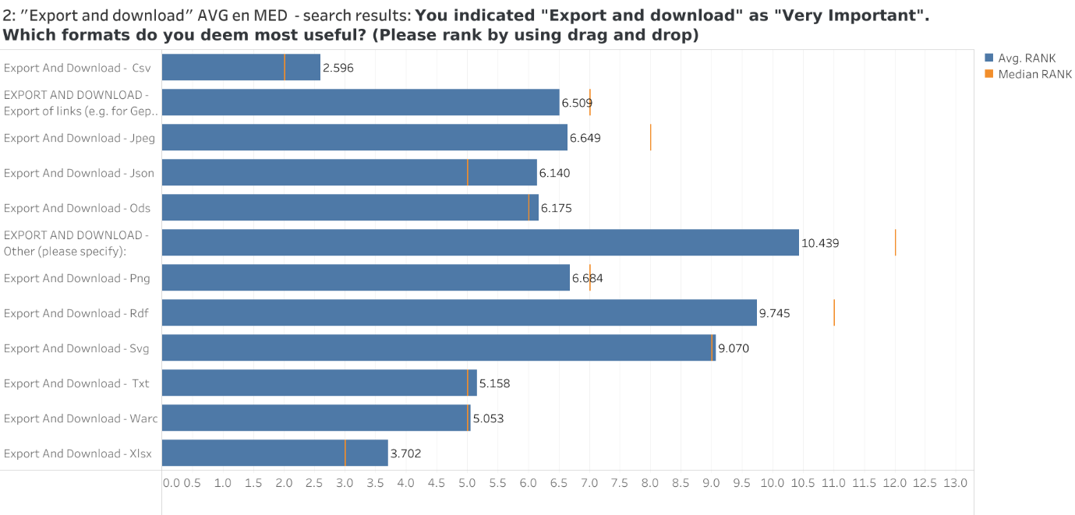
Note: Respondents were asked to rank the items from most useful (ranked as 1) to least useful (ranked as 14). A lower number indicates a higher usefulness. This graph is not included in the Tableau dashboard since this question was not presented to everyone, only the respondents who indicated “Advanced search” as “Very Important”.

More detail on filters (respondents who have indicated “filters” as “very important”)
In the context of image-based search, the ranking results reveal a clear set of filter preferences, emphasizing precision, relevance, and contextual control. At the top of the list is the URL filter, which received the highest usefulness ranking with an average score of 3.13. This reflects the strong user need to locate specific archived images by their original web address, underscoring the value of traceability in working with visual content.
Following closely are filters for type (e.g., web page, document, image), domain, capture date or range of dates, and subject term, all averaging between 5.38 and 5.75. These filters provide structure to image-based discovery, helping users focus on particular content formats, source websites, relevant timeframes, and thematic categories. Their high ranking signals a clear expectation that image search should be both targeted and richly contextualized.
Mid-tier preferences include filters such as MIME/file type, language, and name of collection, which were ranked slightly lower, with average scores between 6.63 and 7.38. These allow users to refine their searches further based on technical file characteristics, language metadata, or archival curation, and are useful complements to more central filters like URL or subject.
Filters such as top-level domain, number of captures, access conditions, status code, and location were consistently ranked lower, with average scores from 8.38 to 9.88. These metadata dimensions, while still potentially relevant in administrative or curatorial workflows, appear to be less critical for users conducting visual searches—likely because they relate more to the infrastructure of the archive than to the content of the images themselves.
The “other” responses added further insight into how users interpret and prioritize filtering options. One respondent questioned the usefulness of filters like URNs or persistent identifiers and full-text content, ranking them as least useful (14), possibly due to their limited application in the visual context. Another raised the issue of potential redundancy between type and MIME type, suggesting that clearer distinctions or consolidation might be necessary to avoid confusion. Similarly, one respondent questioned whether filters such as domain and top-level domain offer truly distinct value from the more general URL filter, implying that a more streamlined approach could improve usability.
These additional perspectives reinforce a broader point emerging from the data: while users appreciate a wide array of filtering options, they gravitate most strongly toward filters that directly enhance content discovery—especially those that offer specificity (like URL), context (like capture date or subject), and content format (like type). Filters that are more technical or archival in nature may still serve important back-end functions but are not the primary tools users rely on for visual search.
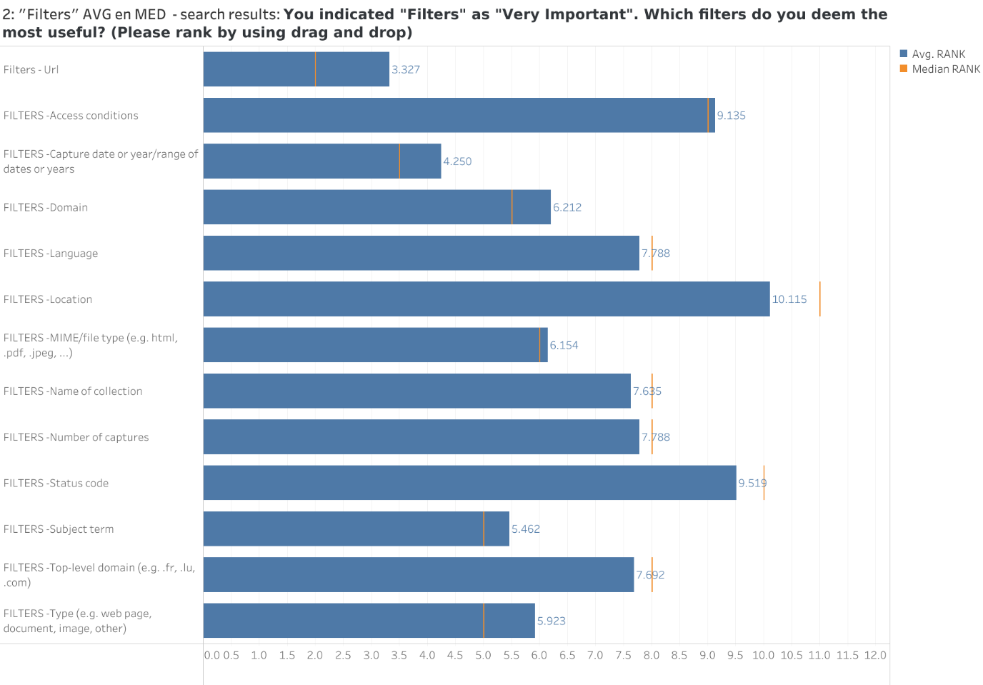
Note: Respondents were asked to rank the items from most useful (ranked as 1) to least useful (ranked as 14). A lower number indicates a higher usefulness. This graph is not included in the Tableau dashboard since this question was not presented to everyone, only the respondents who indicated “Advanced search” as “Very Important”.

More detail on sorting and ranking of results (respondents who have indicated “sorting and ranking of results” as “very important”)
When it comes to how search results should be sorted and ranked, respondents showed a clear preference for functionalities that directly improve relevance and recency in their research workflows.
The most highly valued option was ranking by relevance, which received the top average ranking of 1.83. This indicates that users prioritize systems that surface the most contextually appropriate results first, rather than relying on rigid or default sort orders. Close behind was ranking by latest first / oldest first, with an average score of 1.94—a strong signal that chronological control is also key, especially for those working with time-sensitive or historically contextual content.
Sorting results alphabetically (ascending/descending) received a slightly lower score (2.71), suggesting that while useful for some tasks, this method is less aligned with the exploratory or interpretive needs of researchers. It may be more applicable in administrative or metadata review contexts than for primary discovery.
The least prioritized feature was the ability to choose the number of results displayed per page, which had the highest average rank (3.51). This suggests that while pagination control can enhance usability, it is not central to how users define the usefulness of search result interfaces.
Overall, the data highlights a strong preference for sort and ranking functionalities that enhance the intellectual relevance and temporal control of search output. Layout and display preferences, by contrast, are helpful but secondary to content-centered ranking mechanisms.

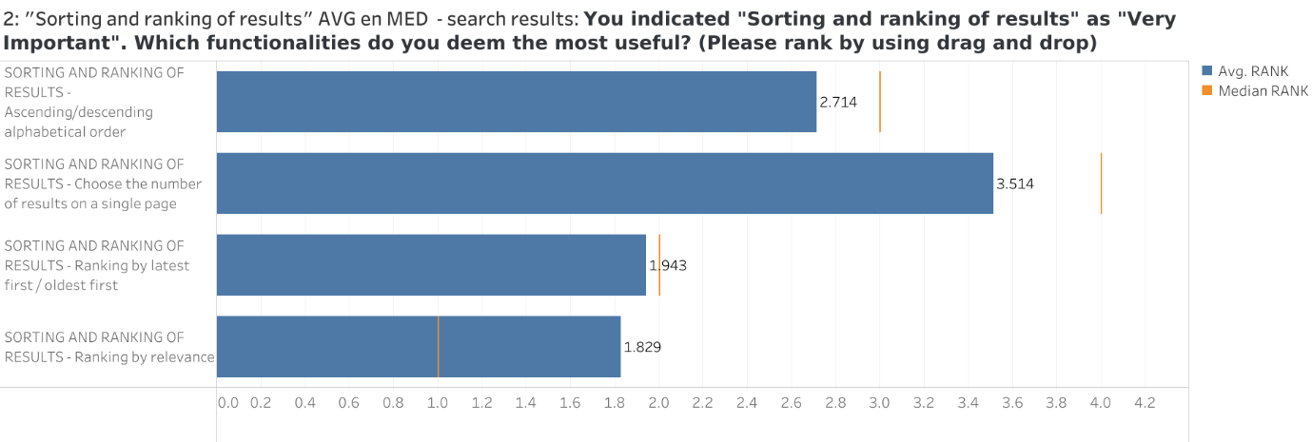
Note: Respondents were asked to rank the items from most useful (ranked as 1) to least useful (ranked as 14). A lower number indicates a higher usefulness. This graph is not included in the Tableau dashboard since this question was not presented to everyone, only the respondents who indicated “Advanced search” as “Very Important”.

More detail on summary/statistics of the results (respondents who have indicated “summary/statistics of the results” as “very important”)
Among respondents who rated summary/statistical functionalities as very important, clear preferences emerged for tools that offer insight into the scope, structure, and evolution of archived content. The highest-ranked feature was the ability to view statistics about the evolution of the number of captures or URLs per year, with an average rank of 2.91. This reflects a strong need for time-based insights, allowing users to detect trends, activity spikes, or historical gaps in the archived material.
Also highly valued were overviews of the MIME type distribution (3.77) and top hashtags, mentions, links, users, and media from social media (3.82). These features offer both technical and thematic summaries, helping users quickly understand the content formats present in their results and identify key topics or actors in social media archives.
The option to view a list of the last 10 captures with hyperlinks to relevant content also received a high ranking (4.23), indicating the importance of quick, actionable access to specific, recent examples from the archive.
Slightly lower in priority were statistics on country/city distribution (4.36), number of incoming and outgoing links per year (4.36), and language distribution (4.55). While still considered useful, these geographic, network-based, and linguistic insights appear to be seen as secondary compared to features that highlight content dynamics and technical structure.
An “other” response specifically mentioned retweets as a valuable metric, pointing to interest in tracking engagement and circulation patterns in archived social media content. Although not included in the predefined list, this response highlights a broader desire to capture social interactions and virality as part of the summary layer.
Overall, the findings show a clear preference for summary statistics that provide immediate, meaningful overviews of content activity and structure—particularly through temporal trends, file format breakdowns, and topical highlights. More contextual or infrastructural statistics remain useful but are not prioritized to the same degree.
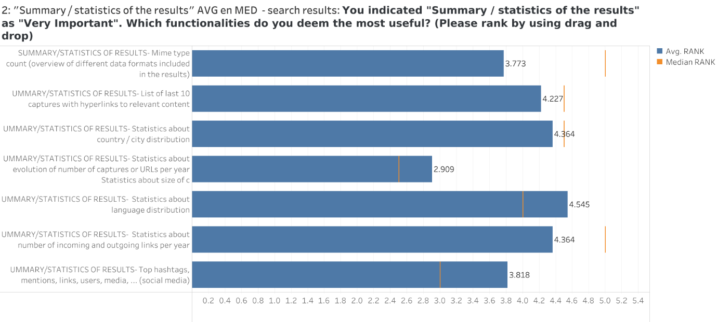
Note: Respondents were asked to rank the items from most useful (ranked as 1) to least useful (ranked as 14). A lower number indicates a higher usefulness. This graph is not included in the Tableau dashboard since this question was not presented to everyone, only the respondents who indicated “Advanced search” as “Very Important”.

3.3.3 Assuming there are no practical or legal hurdles, how do you see the access to a web and social media archive via a user interface?
The survey results reveal a consistently ambitious, open, and multifaceted vision for an ideal user interface to access web and social media archives—assuming no practical or legal barriers. The strongest consensus centers around accessibility, customizability, and functionality tailored to both expert researchers and the general public. Users overwhelmingly advocate for open, free, and remote access, with options to download content and build personalized corpora. Many envision interfaces that blend the familiarity of search engines or library catalogues with advanced tools specific to web archives, such as timeline navigation and version comparison.
A recurring theme is customization and personalization. Users want accounts to track searches, save favorites, and create sub-collections or annotations. Importantly, they emphasize substance over style—preferring a "difficult but powerful" interface to a sleek but limited one. Features like full-text and hashtag search, advanced filters (e.g., by frequency of change or metadata fields), and side-by-side comparison of different versions of a webpage are seen as essential.
Visual tools—such as calendars marking changes between snapshots, graph-based views, or replay features resembling the Wayback Machine—are strongly favored. Some imagine enhanced experiences with visual change detection, voice search, and even interactive annotations. Interfaces should offer full-screen, unobstructed replays of archived content to preserve context and readability, not windowed or shrunken views.
Several contributors stress the importance of educational support, such as video tutorials or guided walkthroughs, especially for non-experts. Others highlight the value of dual-mode access: simple and intuitive for the general public, yet robust and data-rich for advanced users.
Ultimately, the ideal interface is one that supports diverse modes of research—browsing, mining, annotating, comparing, and exporting—while remaining user-friendly, transparent, and inclusive. It balances open discovery with personal control, integrates AI-powered insights without obscuring original content, and respects both the depth of scholarly inquiry and the curiosity of casual users.

3.3.5 Functionalities API
APIs that enable straightforward data retrieval and provide comprehensive access to metadata are considered essential by the majority of respondents. Content retrieval and access ranked as the top priority, with 85% of respondents rating it as very important. Closely following was metadata access and search, which 79% of respondents also rated as very important. These results highlight the fundamental role of APIs in supporting programmatic access to archival content and metadata—an indispensable feature for researchers seeking to automate and customize their data collection processes.
Data export and interoperability was another highly valued functionality, marked as very important by 69% of participants. This reflects a widespread need for open and flexible systems that allow integration with other tools and workflows, supporting reproducibility and collaboration across projects and institutions.
Slightly lower in priority—but still important—were features such as temporal navigation (52% very important), which allows users to explore archived materials over time, and content replay (42%), which supports re-experiencing captured web content in its original form. While not the top priorities, these functionalities contribute significantly to contextual understanding and the usability of archived resources.
Entity recognition, though rated as very important by 33% of respondents, received a majority of somewhat important responses (54%), indicating a more moderate but still present interest in enriched, semantically aware APIs. Lower-priority features included general statistics (27% very important) and usage tracking (14% very important), both of which saw higher levels of disinterest—particularly usage tracking, which was marked as not important by nearly a third of respondents (31%).
The “other” responses further underscore core infrastructural needs. Several respondents emphasized the importance of exposing fundamental archival identifiers through the API, such as unique IDs, URLs, timestamps, and domain information. These elements are crucial for maintaining reference integrity and enabling consistent cross-referencing between systems. One respondent specifically noted the value of adding the original URL to the archive, reinforcing the importance of transparent traceability between source and archive. Another identified Memento support as a very important feature, referencing the need for standardized, time-based access mechanisms that allow users to retrieve archived versions of web pages using original URLs and datetime negotiation.
Altogether, the responses reflect a clear expectation for APIs to provide robust, efficient, and flexible access to archival data. While advanced enrichment features are appreciated, the highest priorities remain those functionalities that directly support scalable retrieval, precise referencing, and metadata clarity—tools essential for both computational analysis and long-term scholarly use.

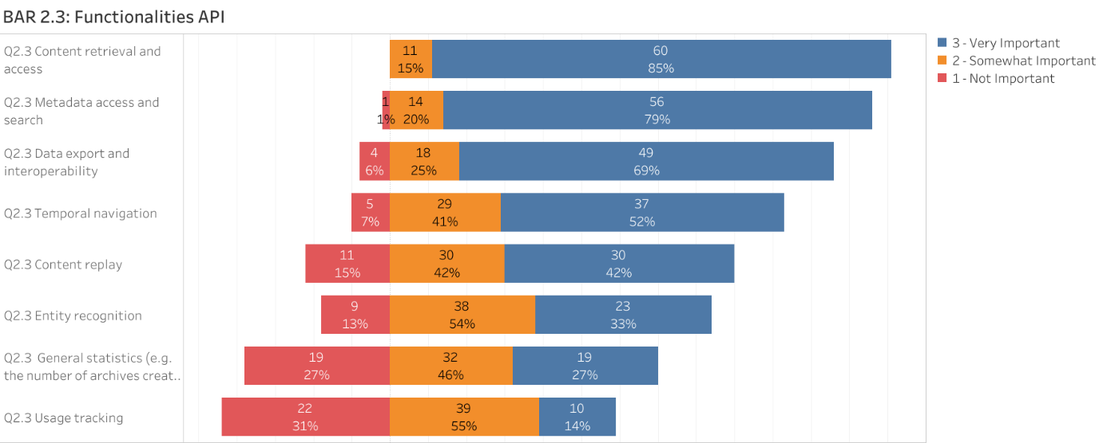

3.3.6 Assuming there are no practical or legal hurdles, how do you see the access to a web and social media archive via API?
Survey responses indicated that, assuming no practical or legal hurdles, API access to web and social media archives is envisioned as a powerful and transformative gateway—providing flexibility for developers and scalability for researchers. The ideal setup would provide well-documented, standardized APIs (e.g. RESTful APIs based on international frameworks like Memento and Event Notifications) that allow users to retrieve not just raw data (e.g. WARC files or HTML snapshots), but also enriched, structured content optimized for analysis or playback.
A best practice API would offer multiple data formats (JSON, CSV, WARC, XML, RDF), with advanced search capabilities—such as filtering by date ranges, domains, content type, or even rate of change between versions. Downloading entire corpora, retrieving statistics, and customizing content extraction workflows would be core features. It would also support real-time querying and automated notifications for new captures or updates, potentially allowing users to subscribe to specific topics or URLs of interest.
Recognizing that APIs can be technical barriers, the archive should offer interactive learning tools such as Jupyter notebooks, use-case tutorials, and GUI-assisted query builders. This bridges the gap between occasional users and technical researchers. APIs could also enable users to contribute content (suggest URLs for archiving or annotate data), adding an interactive, participatory dimension to preservation.
Crucially, respondents emphasize that API access must be equitable—free, or at least publicly accessible, and not locked behind institutional logins or subscriptions. While APIs favor technically skilled users, transparency and solid onboarding tools can ensure broader engagement. Ultimately, open and robust API access would not only solve many access-related problems but also empower new forms of research, teaching, and public engagement with digital heritage.

3.3.7 Best practice in terms of access and API
A best practice for access and API in the context of web and social media archiving would combine openness, usability, and standardization, ensuring that both expert researchers and the general public can interact meaningfully with archived content. Arquivo.pt and the Wayback Machine stand out as widely cited examples due to their accessibility, comprehensive data coverage, and intuitive user interfaces. These platforms allow users to retrieve full archived content, not just metadata or CDX indexes, which is critical for robust research and digital preservation.
Equally important are clear, well-documented, and standardized APIs, ideally aligned with international efforts to create interoperable systems. Respondents emphasized that API documentation must go beyond technical specs—it should include tutorials, real-world use cases, and community support to lower barriers to entry. The former Twitter Academic Research API was often cited as a model because of its rich metadata, advanced filtering options, and scalable access—features that enabled impactful research on digital discourse and social trends before it became restricted.
Another strong recommendation is to build APIs with and for the user community: gather feedback early, prioritize transparency, and aim for APIs that replicate the full functionality of the user interface (e.g., replay views, filtering by content type, metadata export). Tools like Social Feed Manager were mentioned as best practice examples for their flexibility, support for multiple formats (JSON, WARC), and archival reliability.
Finally, best practice also includes responsible access: implement notice-and-takedown mechanisms for sensitive content, and consider open access across borders to support transnational research. A shared global standard for web archive APIs—rooted in collaboration rather than reinvented locally—was seen as essential to future-proofing access and expanding the usability of web and social media archives.

3.3.8 Combined Insights from workshops – Access
Participants from both workshops emphasized the need for access systems that cater to a wide range of users, from casual browsers to expert researchers. There was consensus that access platforms should offer layered functionality, combining intuitive and accessible user interfaces with more complex tools for advanced querying, filtering, and data manipulation.
Remote and open access was regarded as essential. Users expressed a strong desire to download structured datasets directly and to preview these datasets before committing to a download. They also stressed the importance of good documentation, both for the content and the tools used to access it.
Well-documented and customizable APIs were also a recurring need, particularly APIs that support popular data formats like JSON, CSV, and WARC. Users valued interoperability and scalability, and appreciated when platforms provided integrations with analytical environments such as Jupyter Notebooks and SPARQL endpoints. Another key point was the desire to maintain the original look and feel of web content. This visual fidelity was seen as important for contextual research. Participants also called for features that support chronological navigation, graph-based data visualization, and replay of web snapshots, allowing users to trace changes over time.
These expectations reflect a broad vision of access that is not only technically robust but also transparent, user-friendly, and flexible enough to support different research styles and levels of expertise.

3.4 Topic 3 “Researcher needs in terms of content enrichment and implementation for enrichment”

3.4.1 State of the art of content enrichment
Once the WARC files containing the archived web content are created, subsequent methodologies can be implemented to generate metadata, which in turn facilitates search capabilities. Several methodologies exist for metadata creation. This section will focus on methods based on Generative Artificial Intelligence.

Challenges in generating accurate and comprehensive metadata from WARC files include data variety, as they contain diverse types such as HTML, images, and PDFs. Data volume is another obstacle, since files can be large, making processing computationally intensive. Additionally, data quality is often an issue, as archived web content may be incomplete or poorly formatted. Ensuring metadata consistency across different sources and periods is another issue.

LLMs (Large-Language Models) solve metadata generation challenges that were previously not possible through classical NLP (Natural Language Processing). LLMs can analyze text content in WARC files to extract information, summaries, identify entities, suggest related topics, keywords, and classifications. Generative AI also provides content understanding by interpreting context and semantic meaning, leading to more accurate metadata. Multimodal LLMs allow processing other data types like images and videos.

Several approaches can be explored to leverage Generative AI for metadata generation from WARC files.
Text Extraction and Summarization: One area involves using LLMs to extract essential text from HTML and other text-based content within WARC files. Furthermore, LLMs can be employed to identify named entities such as people, organizations, and locations, as well as the relationships between them.
Image and Multimodal Analysis: Another approach focuses on extracting metadata from visual content. This involves employing Visual LLMs for object recognition, scene description, and generating image captions. The goal is to combine text and image analysis to create metadata for web pages that feature multimedia content. Additionally, Optical Character Recognition (OCR) is used to extract text from images and PDFs, with LLMs then processing this extracted text for further analysis.
Classification and Categorization: LLMs can classify web content into predefined categories or taxonomies, which helps in organizing a given set of WARC files. Generative models can also suggest relevant keywords and tags for web pages, which can improve searchability. Beyond categorization, downstream methods can also be used to build knowledge graphs or ontologies based on the extracted metadata, which can also improve content organization and retrieval.
Metadata Standardization and Quality Control: If given a schema, LLMs can be used through a method called constrained decoding, where schemas or templates are used to ensure that the generated metadata abides by a specific format. This standardization enables long-term usability. Moreover, validation and quality control mechanisms can be used to identify and correct errors in the generated metadata that follows a particular schema. LLMs are also playing a role in evaluating the quality and completeness of existing metadata and suggesting improvements, leading to more accurate and reliable metadata records.

3.4.1 Content enrichment
Metadata enhancement and content quality checks emerged as the most important enrichment functionalities for respondents. A strong majority—73%—rated metadata enhancement (covering descriptive, technical, or provenance metadata) as very important, with an additional 27% marking it as somewhat important. Similarly, content quality checks were highly valued, with 55% rating them as very important and 36% as somewhat important. These responses reflect a clear consensus on the foundational role of metadata and quality assurance in ensuring the reliability, interpretability, and long-term usability of archived content.
The emphasis on metadata was further echoed in an “other” response, which highlighted the importance of extracting granular metadata directly from the content, such as language and other embedded properties. This suggests a growing demand not only for comprehensive metadata records but also for automated tools capable of generating detailed and context-specific metadata that enhance discovery and analysis.
While metadata and quality checks lead in importance, other enrichment features also garnered interest, though with a broader spread in perceived value. Just over half of respondents considered copyright information and the ability to recreate the original look and feel of web content to be very important (51% and 47%, respectively), suggesting that authenticity and legal clarity also play important roles in enrichment.
More exploratory or analytical features—such as displaying named entities in the search interface (43% very important), contextualizing with related content (46%), or annotations (36%)—were rated somewhat lower in priority but still significant, especially when considered alongside the relatively small proportion of respondents who marked them as not important.
The lowest-ranked enrichment options included clustering of content (31% very important), clustering of images (32%), and geographic visualization of places on a map (28%). These were also the features with the highest percentages of respondents rating them as not important (ranging from 16% to 24%), indicating that while these tools may offer valuable insights in certain contexts, they are not universally prioritized.
Overall, the data reflects a strong baseline expectation for enrichment practices that ensure content is both accurate and richly described. At the same time, there is openness to more advanced enrichment tools, particularly those that can support discovery, contextualization, and analysis—provided they are balanced with practical considerations and core metadata needs.

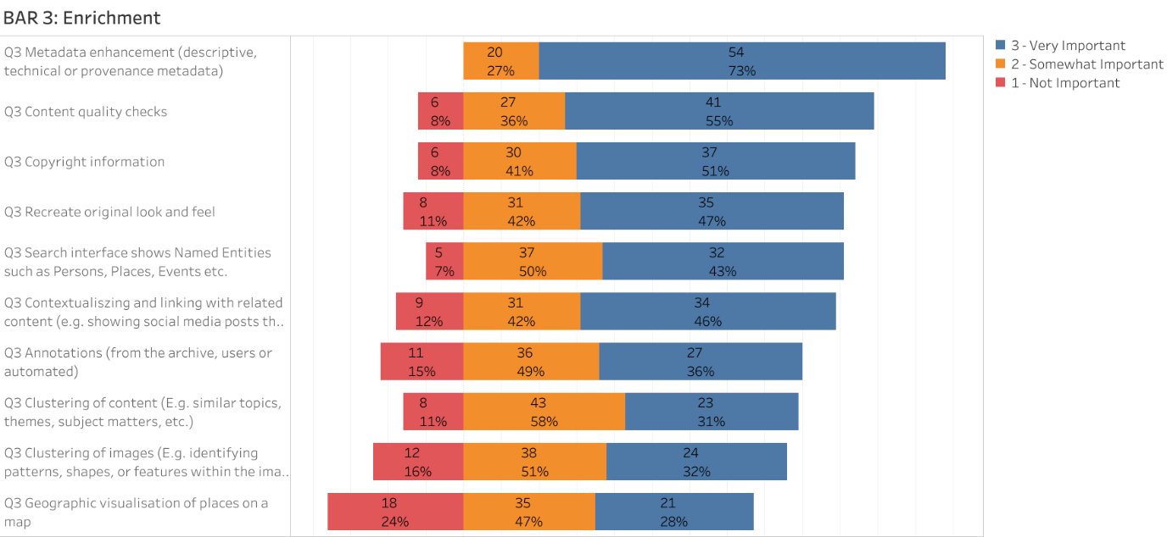

3.4.2 Assuming there are no practical or legal hurdles, how do you see the enrichment of web and social media archived content?

The data collected reflects a diverse yet converging vision for the enrichment of web and social media archives. A central conclusion is that enrichment should align with the same standards and principles applied to traditional libraries and archives—treating web content as both data and cultural heritage. High-quality metadata remains crucial, particularly provenance information, dates of crawl, tools used, and the context of capture, as these help researchers assess the integrity and evolution of content over time.

There is strong support for using linked data to interconnect disparate sources, enabling more meaningful search and discovery. While modern AI tools hold great promise for tasks like entity recognition, sentiment analysis, and multilingual tagging, participants caution against over-reliance on algorithmic clustering, which can bias research and obscure nuance. Instead, combining AI-driven automation with curator and user-led annotation—ideally supported by platforms that allow tagging, personalized metadata views, or even Genius-style community annotations—emerges as a preferred model. International collaboration and crowdsourcing (with quality checks) are also seen as ways to overcome siloed or resource-constrained efforts. Ultimately, enrichment must remain transparent, user-focused, and sustainable, enhancing both qualitative and quantitative research without compromising interpretability or access.

3.4.3 Best practices for enriching
The responses suggest that best practices for enriching web and social media archives center on a combination of technological sophistication, participatory approaches, and long-term policy planning. A frequently cited example is Ina (Institut national de l’audiovisuel) in France, recognized for its innovative integration of audiovisual and social media content, creating layered, cross-referential archives that enhance discoverability and research potential. Similarly, Common Crawl is noted for its large-scale enrichment through structured metadata, entity recognition, and link analysis—making it a benchmark for computational research.
Several contributions highlight that enrichment should begin at the point of capture, embedding metadata that explains both the content and its archival rationale. Later enrichment—whether via researchers, users, or collaborative sub-collections—can add layers of interpretive value. Participatory enrichment is emphasized throughout: from user annotations and tagging to crowdsourcing and peer-review mechanisms to validate contributions.
Investing in common protocols, such as Signposting, is seen as a strategic move—establishing "Archive-SEO" (Search Engine Optimisation) standards akin to search engine optimization to incentivize better metadata practices on the open web. Additional best practices include providing exportable linked data, ensuring accurate temporal markers (especially for social media), and supporting tools that document the archiving process and its context.
Overall, a best-practice archive is participatory, standards-driven, and technically equipped—offering transparency, rich contextual metadata, and infrastructure for both user-driven and automated enrichment, ensuring its long-term research value and accessibility.

3.4.4 Combined insights from workshops – Content enrichment
Participants in both workshops considered enrichment an essential part of making archived web and social media content useful for research. A consistent theme was the need for comprehensive and reliable metadata. This includes not just descriptive information but also technical and provenance metadata that detail how, when, and why content was archived.
Automated enrichment methods such as topic modeling, named entity recognition, facial and image recognition, and AI-generated content detection were frequently discussed. These tools were seen as valuable for improving the navigability and analytical utility of large datasets.
Manual and collaborative approaches to enrichment were also emphasized. Participants appreciated the possibility of annotating datasets, linking related collections, and applying contextual insights. Transparency about the enrichment process was crucial. Many participants suggested providing documentation akin to a “model card” that outlines the dataset's origin, scope, limitations, and intended uses.
Finally, participants underscored that ethical enrichment practices are vital. This includes thoughtful handling of sensitive or deleted content, avoiding algorithmic bias in categorization, and clearly labeling automated enhancements to maintain trust and accuracy.

4 Conclusions
The combination of interactive workshops and survey data has provided a comprehensive and multidimensional view of what users expect from web and social media archives. Participants across diverse professional and academic backgrounds expressed clear, consistent needs concerning how content is selected, accessed, and enriched. This report captures those needs in detail, shedding light on current limitations and offering a roadmap for future development.
A central conclusion of this study is the necessity for user-centered design. Whether through intuitive interfaces or advanced APIs, the tools used to explore and interact with digital archives must accommodate different levels of expertise and purposes. The findings demonstrate that researchers, journalists, students, and heritage professionals all need flexible yet robust systems that can scale with their ambitions.
In terms of content selection, transparency and inclusivity were repeatedly highlighted as core values. Participants emphasized that archives must explain how decisions about inclusion and exclusion are made, and they supported participatory models that allow users to nominate or curate materials. At the same time, ethical considerations must guide these processes to ensure the representation of diverse voices and the responsible handling of sensitive content.
With respect to access, users clearly desire more than just visibility. They need systems that enable downloading, filtering, and processing large datasets. Access should be both open and remote, with layered interfaces catering to both casual browsing and intensive analysis. Support for structured formats, metadata transparency, and integration with external research tools are all critical for the use of these archives.
Enrichment was the third topic we focused on importance. Both automated and manual methods of enhancing metadata, linking related content, and annotating datasets were endorsed by participants. Yet the process must be documented, ethically sound, and technically interoperable. Enrichment, when executed thoughtfully, transforms archived content from static records into dynamic research material.
These insights will lay the base for the development priorities of the BelgicaWeb project. The project team now has clear guidance to create systems that reflect users’ real-world challenges and aspirations. Ultimately, this report serves not only as a guide for BelgicaWeb but also as a foundational reference for any initiative that seeks to preserve and provide access to born-digital heritage in a fair, open, and sustainable manner.

Annex I: Outline workshop DH Benelux
See separate document. Also accessible via https://www.sodha.be/dataset.xhtml?persistentId=doi:10.34934/DVN/NHLLHP .

Annex II: Presentation workshop DH Benelux
See separate document. Also accessible via https://www.sodha.be/dataset.xhtml?persistentId=doi:10.34934/DVN/NHLLHP .

Annex III: Outline workshop Praktijknetwerk
See separate document. Also accessible via https://www.sodha.be/dataset.xhtml?persistentId=doi:10.34934/DVN/NHLLHP .

Annex IV: Presentation workshop Praktijknetwerk
See separate document. Also accessible via https://www.sodha.be/dataset.xhtml?persistentId=doi:10.34934/DVN/NHLLHP .

Annex V: Survey questions
See separate document. Also accessible via https://www.sodha.be/dataset.xhtml?persistentId=doi:10.34934/DVN/NHLLHP .

Annex VI: Survey results
See separate document. Also accessible via https://www.sodha.be/dataset.xhtml?persistentId=doi:10.34934/DVN/NHLLHP .

Annex VII: Analysis of access platforms and user interfaces
See separate document. Also accessible via https://www.sodha.be/dataset.xhtml?persistentId=doi:10.34934/DVN/NHLLHP .

Annex VIII: List of questions used for Wooclap
Q1 Which data derivatives would you deem most useful?
Q2 When working with web archives, how important is it to have a folder system to save, structure, and easily retrieve your search results over time?
Q3 How important is Memento support for accessing and integrating web archives across different platforms and time-based versions? (Memento is an addition to the HTTP protocol which allows a client to request an archived web resource from a specific date and time.)
Q4 What kinds of IT support and user training (e.g., tools for distant reading, PDF guides, video tutorials) would help users interact more effectively with web archives?
Q5 How can we also encourage users to actively contribute feedback, share use cases, or help improve the platform?
Q6 How important is it to have tools that visualize changes or differences between multiple versions of the same webpage (e.g., highlighting what has changed across captures)?
Q7 How important is it for APIs in web archiving platforms to support Event Notifications? Event Notifications is a mechanism where the platform can proactively send updates/alerts when specific events occur. Instead of requiring other systems to constantly query the API for changes (a process known as polling), subscribing systems automatically receive a notification.
For example:
A crawl has started, progressed, or completed or.. failed
A new web resource has been successfully captured.
A collection of archived content has been updated.
Archived data is ready for access or export.
Q8 How important is it to enable features such as update notifications and content subscriptions?
Q9 How do you use sound or audio in your research? Feel free to share links to online sound content that we could use as an example in the BelgicaWeb project.
Q10 How important is it to provide stable URIs for captures in web archives? (By stable URI we mean Persistent Web Identifiers used for creating and resolving precise and persistent references to data in web archives).

Annex IX: MoSCoW table outlining the planned development based on survey results
See separate document. Also accessible via https://www.sodha.be/dataset.xhtml?persistentId=doi:10.34934/DVN/NHLLHP .

